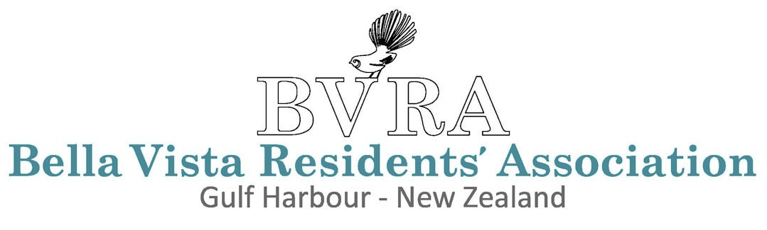
Proxy Voting Form
ANNUAL GENERAL MEETING · GULF HARBOUR, NEW ZEALAND
If you are unable to attend the AGM but wish to cast your vote, complete this form and submit it to the Secretary before the meeting begins.
Please note: only matters included in the published AGM agenda may be discussed or voted upon. In accordance with Rule 17.3, voting is restricted to financial members whose accounts are fully paid.
1. Complete and sign this form. Any material errors or omissions (as determined by the Secretary) will invalidate the form.
2. Appoint your proxy. You may nominate any person, including the Chair or the Secretary. Write “the Chair” or “the Secretary” in the proxy name field, or provide the full name and address of your chosen representative.
3. Submit and notify. Email the completed form to secretary@bvra.nz with a copy (cc.) to your nominated proxy.
This form may be completed electronically — simply click into any field to type your response directly.

Member Details
FIRST NAME |  | LAST NAME

LOT NUMBER |  | EMAIL ADDRESS

Proxy Appointment
I / We (as Owner/s) hereby appoint the following person as my/our proxy
FULL NAME OF PROXY

ADDRESS OF PROXY

to vote on my/our behalf at the Annual General Meeting to be held on Tuesday, 22 April 2026, and at any adjournment of that meeting, on all resolutions requiring a vote of the members.

By submitting this form, I/we confirm that I/we are financial members of the Bella Vista Residents’ Association, that my/our account is fully paid, and that the information provided is accurate to the best of my/our knowledge.
☐ I/We confirm the above and consent to this proxy appointment.

MEMBER SIGNATURE |  | DATE
Bella Vista Residents’ Association · Gulf Harbour, New Zealand · bvra.nz
All proxy appointments are treated in the strictest confidence.

