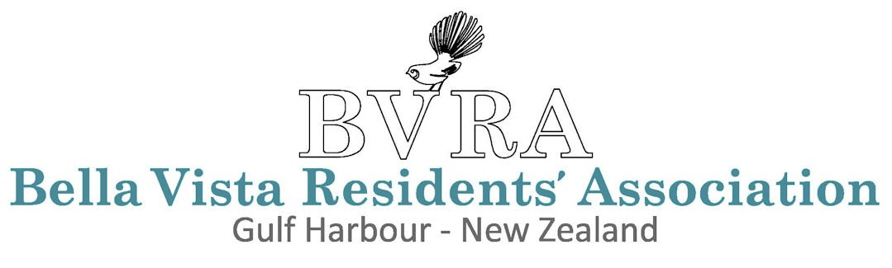
AGM Agenda Submission Form
ANNUAL GENERAL MEETING · GULF HARBOUR, NEW ZEALAND
Members are invited to submit items for inclusion on the agenda of the upcoming Annual General Meeting.
Please note: only items pre-advised to the Secretary and included in the published AGM agenda may be raised at the meeting. Items not listed on the published agenda cannot be considered at the meeting.
Submissions must be made by a financial member of the Bella Vista Residents’ Association. Please provide sufficient detail to allow the Committee to assess each item and indicate whether you wish to present or speak to it at the meeting.
Submissions close: 15 April. Please return this completed form to the Secretary by email or in writing.
This form may be completed electronically — simply click into any field to type your response directly.

Member Details
FIRST NAME |  | LAST NAME

HOUSE NUMBER |  | EMAIL ADDRESS

PHONE NUMBER (optional)

Please remember to use Page 2 to sign and date your submission.
Agenda Item Submissions
Agenda Item 1
ITEM TITLE / SUBJECT

DESCRIPTION (Please describe the item and the outcome you are seeking)

Do you wish to present or speak to this item at the AGM?
☐ Yes ☐ No ☐ To be confirmed

Agenda Item 2 (if applicable)
ITEM TITLE / SUBJECT

DESCRIPTION (Please describe the item and the outcome you are seeking)

Do you wish to present or speak to this item at the AGM?
☐ Yes ☐ No ☐ To be confirmed

Agenda Item 3 (if applicable)
ITEM TITLE / SUBJECT

DESCRIPTION (Please describe the item and the outcome you are seeking)

Do you wish to present or speak to this item at the AGM?
☐ Yes ☐ No ☐ To be confirmed

By submitting this form, you confirm that you are a financial member of the Bella Vista Residents’ Association and that the information provided is accurate to the best of your knowledge.
☐ I confirm the above and consent to this submission being considered for inclusion on the AGM agenda.

MEMBER SIGNATURE |  | DATE
Bella Vista Residents’ Association · Gulf Harbour, New Zealand · bvra.nz
All submissions are treated in the strictest confidence.

